Research Proposal
The proposal must say:
- What the research is about? A description of the research issue.
- How it will be undertaken? Methods, and other issues.
- Why it is worthwhile? Why is the issue important or relevant.
- How long it will take
- Why it should be funded?
Basic structure:
- Introduction
  - Describe the issue/ Objectives/ Relevance/ who will benefit
  - Research Question/ Hypothesis
- Literature review
  - Just and indicative lit review.
- Methods
  - Need to state the research framework (epistemology, ontology)
  - Methods:
    - Data collection process and its appropriateness
    - Population and sampling
    - Data analysis strategy
    - Ethical issues
- Dissemination
  - What you will do with the research
- Timetable
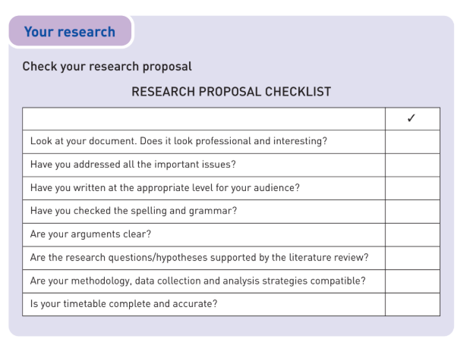
  - Proposed timeline of the different stages
In essence, you are trying to persuade then that you can complete a research project.

